📝 Introduction

This tutorial is about the concept of ARP and default gateways in network. Task 1 involves the use of ARP to monitor the way devices associate IP addresses with hardware (MAC) addresses on a LAN. In Task 2, default gateways are configured to allow communication between different subnets using routers.

Task 1 investigates the ARP mapping of IP addresses to MAC addresses and ARP table updating.
Task 2 is the setting up of default gateways that will facilitate the communication between various subnets.

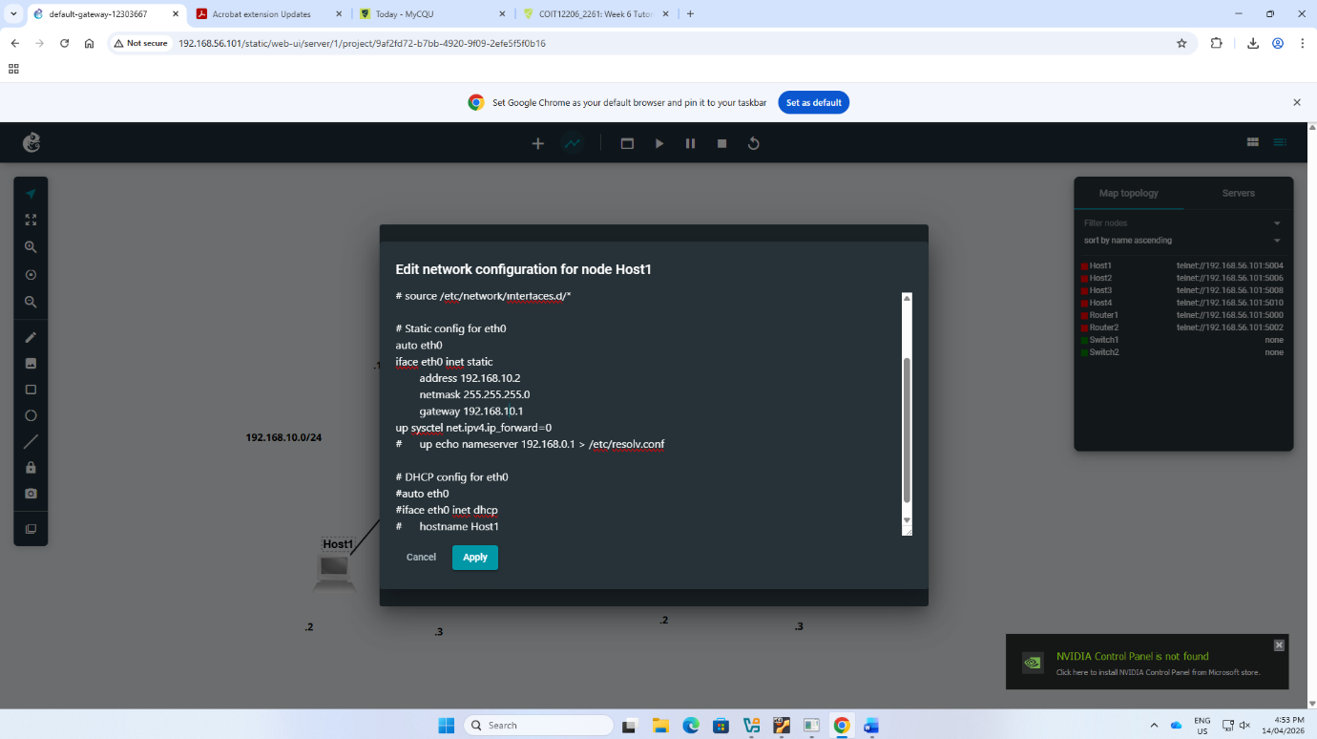
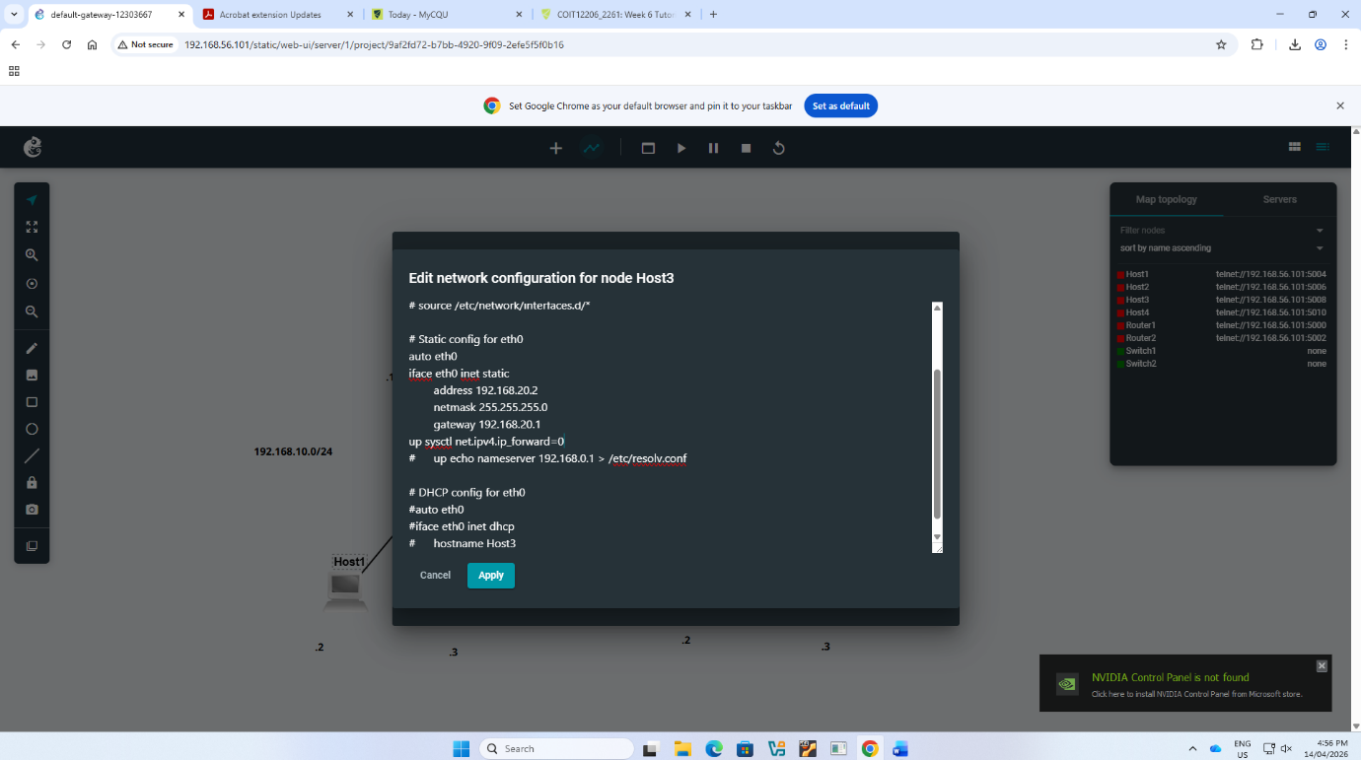
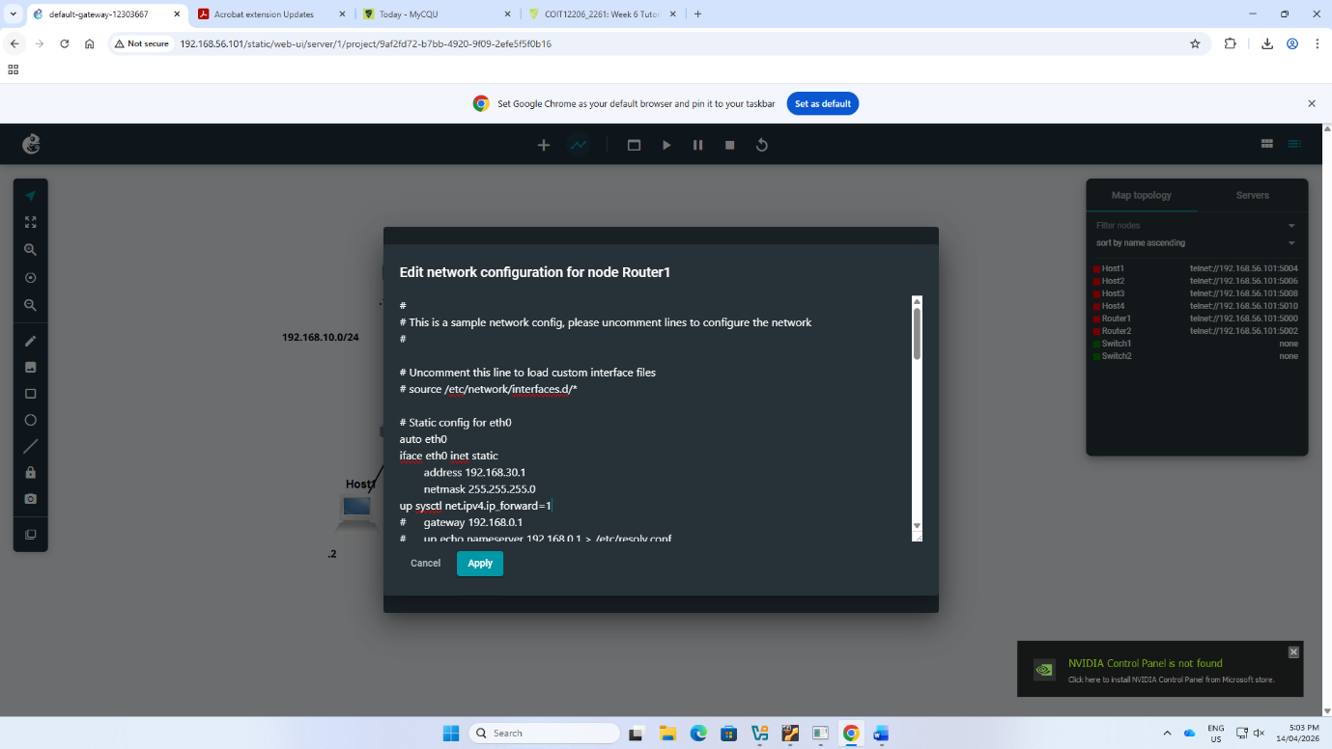
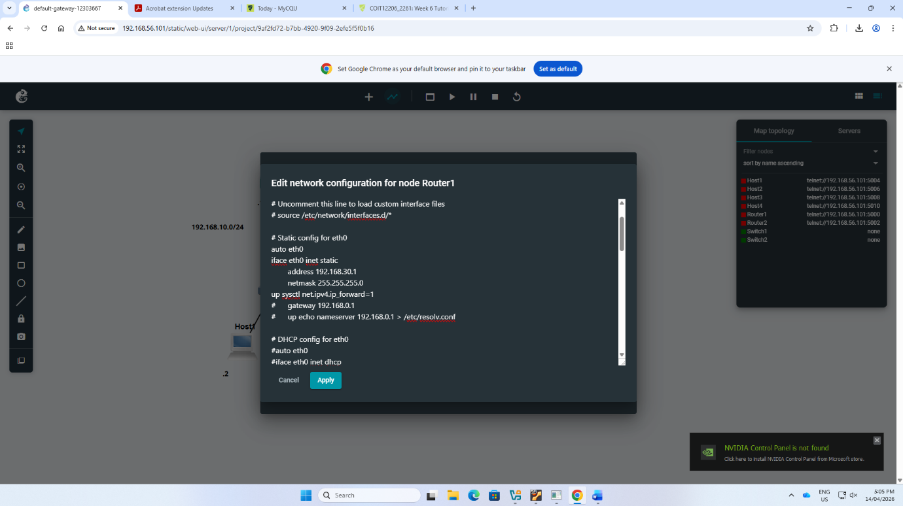
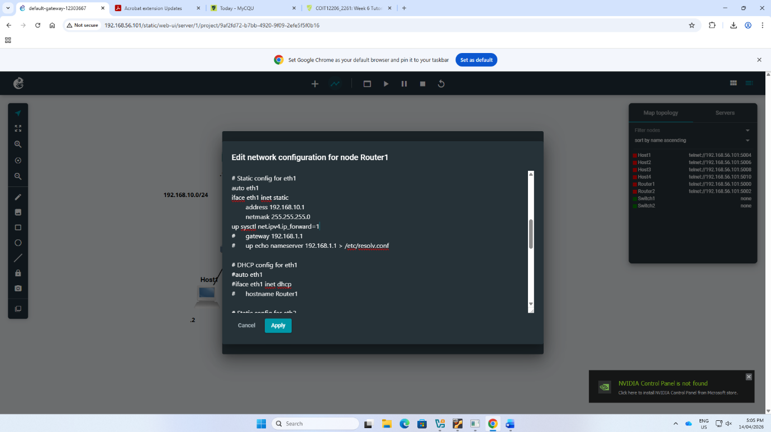
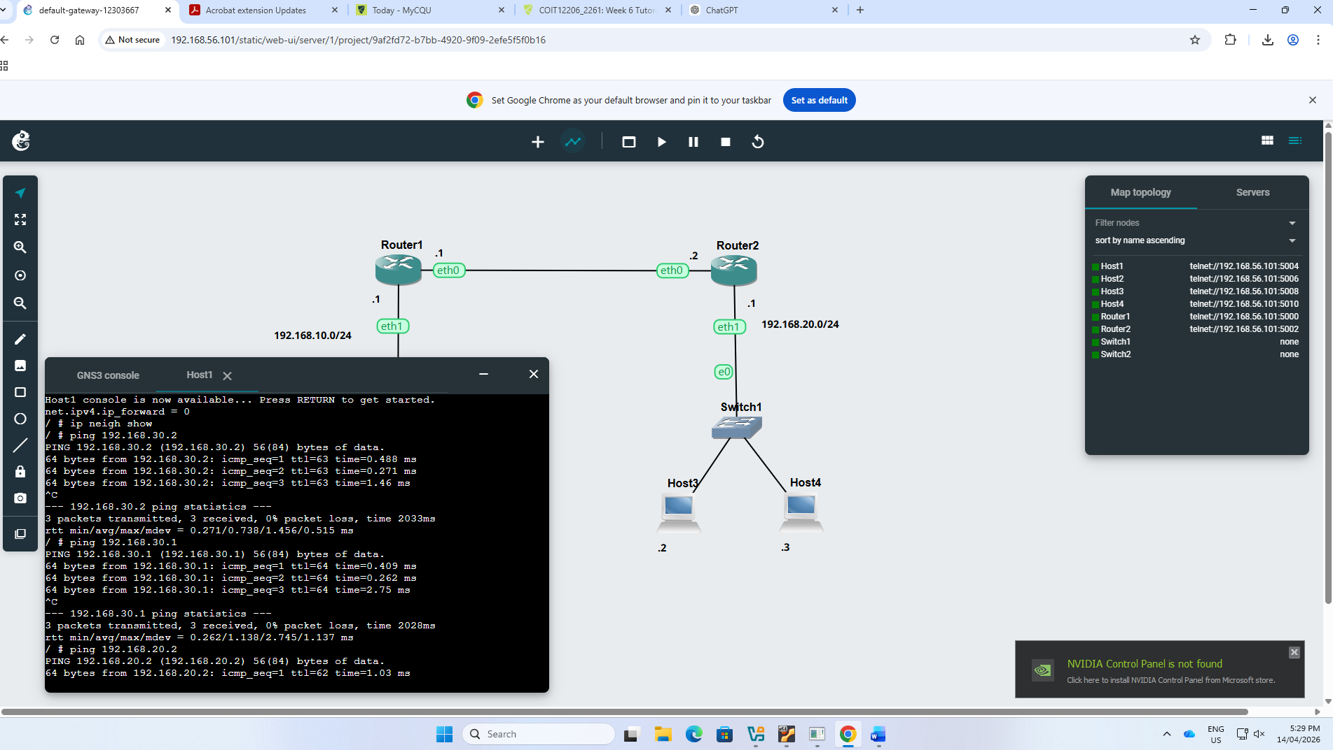
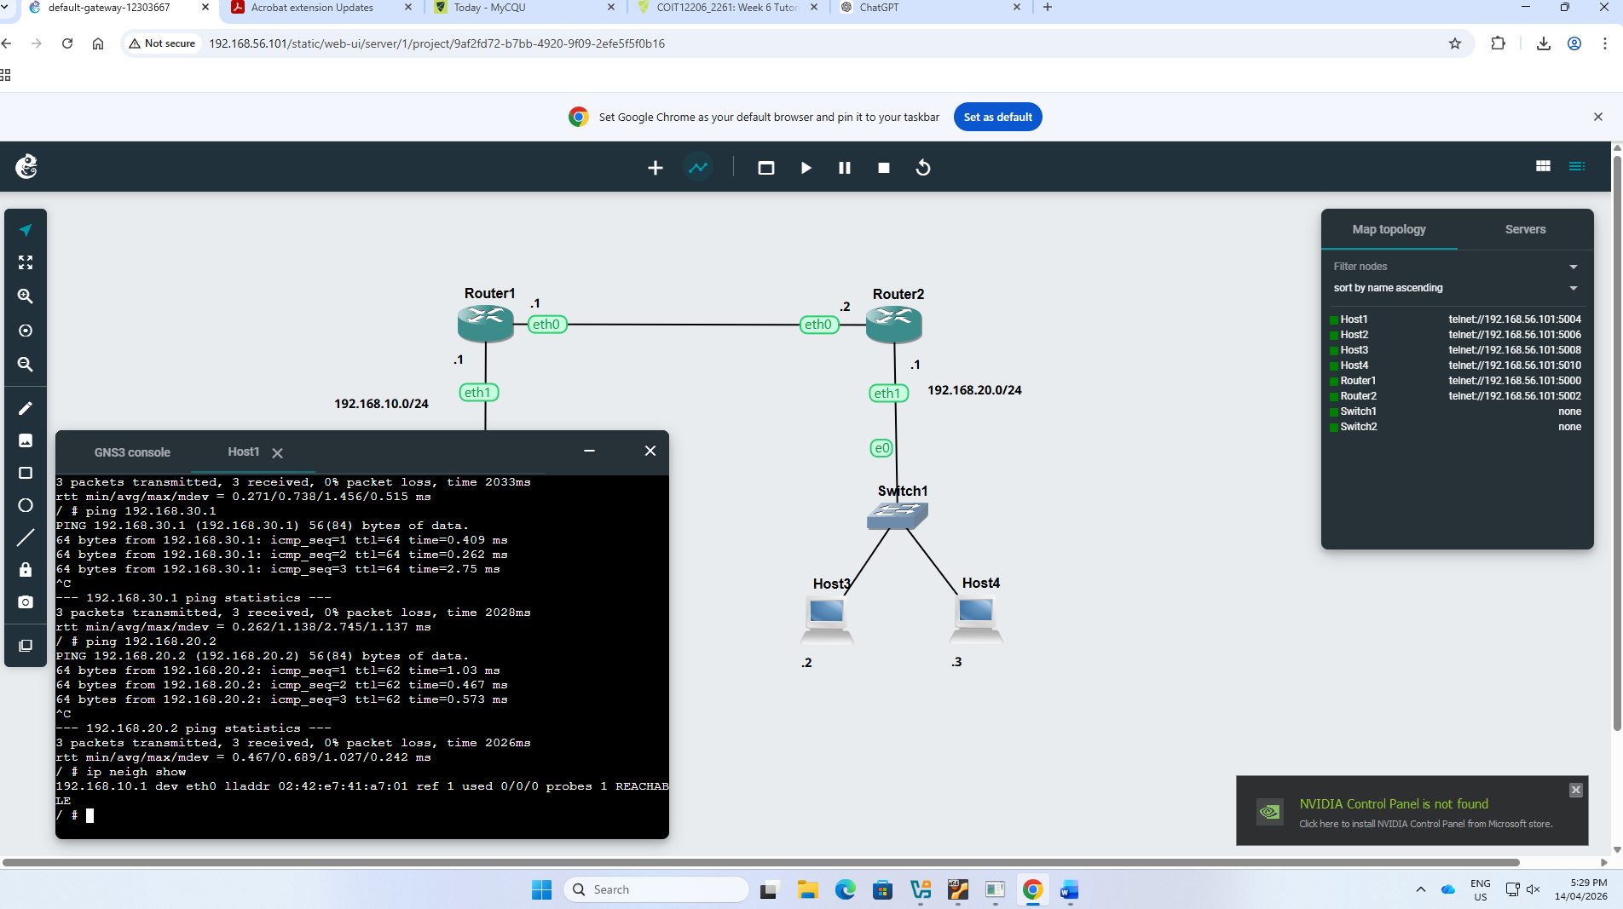
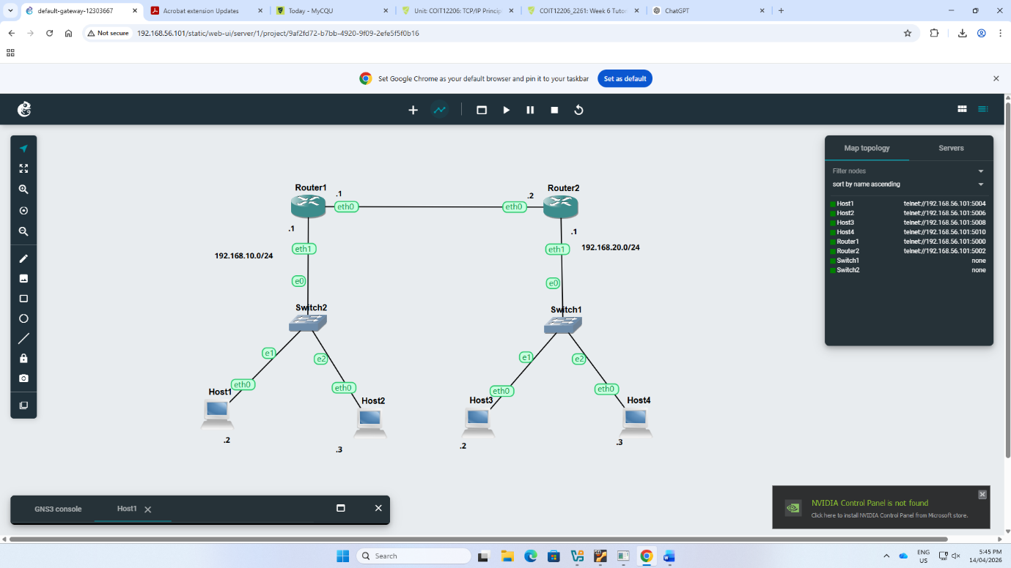

🔍 Reflection

This tutorial made me realize how ARP functions in determining IP addresses to MAC addresses and the process of updating ARP tables when devices interact. The process became more evident by observing the changes in the ARP table.

I also got to know the role of default gateways which enable communication of devices in other subnets using routers. Setting up routing tables and using ping enhanced my knowledge of the process of packets being sent around networks.

